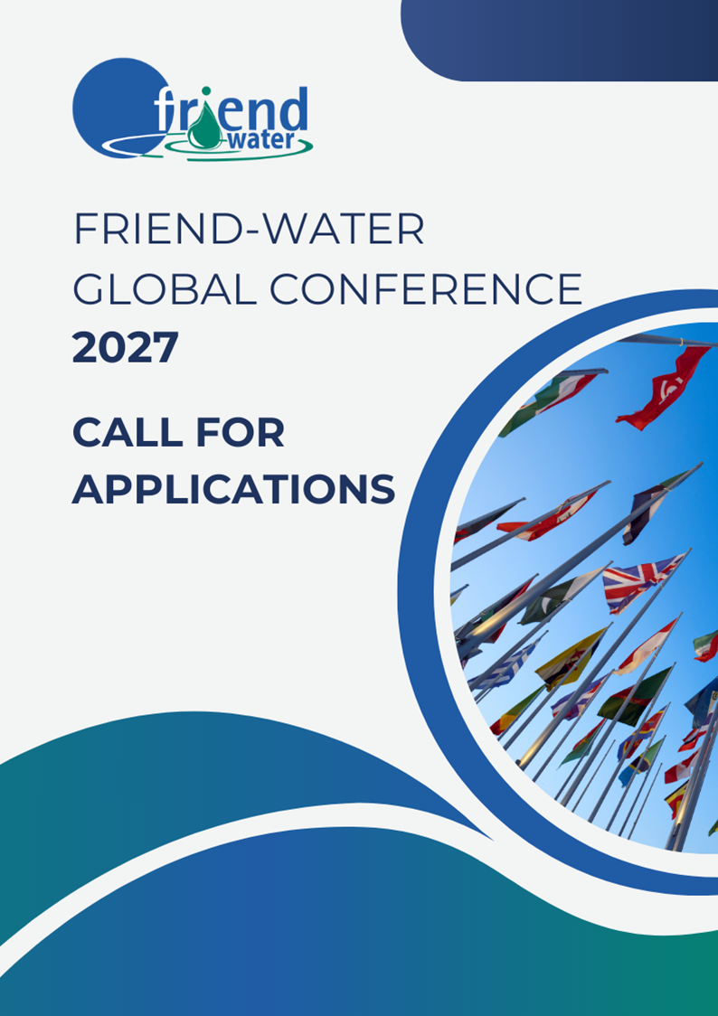

Call for Applications to host the 2027 Global FRIEND-Water Conference

The UNESCO IHP FRIEND-Water programme is seeking applications from institutions interested in hosting the next Global FRIEND-Water Scientific Conference in 2027. This flagship conference brings together the international FRIEND network every four years to advance collaborative hydrological research, strengthen data-sharing, and support capacity building for young scientists. **Deadline to submit your application**: **31st October 2025**.

# Host Institution & Local Organisation

Name(s) of hosting/co-hosting institution(s) and contact persons.

|  |  |
| --- | --- |
| Host | |
| Name of institution | Name of institution. |
| Project Focal Point:  Name: Name  Email : Contact email | Primary Responsible Officer:  Name: Name  Email: Name |
| Co-host (please add more lines if necessary) | |
| Name of institution |  |
| Project Focal Point:  Name: Name  Email : Contact email | Primary Responsible Officer:  Name: Name  Email: Contact email |

Local organising committee: potential members and their expertise in water sciences.

|  |  |  |  |
| --- | --- | --- | --- |
|  | Name | Type of actor  (universities, ministries, agencies, associations, etc.) | Job title |
| 1 | Name | Type | Fonction |
| 2 | Name | Type | Fonction |
| 3 | Name | Type | Fonction |
| 4 | Name | Type | Fonction |
| 5 | Name | Type | Fonction |
| 6 | Name | Type | Fonction |
|  |  |  |  |
|  |  |  |  |
|  |  |  |  |
|  |  |  |  |
|  |  |  |  |

Relevant previous experience in organizing scientific events (national/international).

|  |  |
| --- | --- |
| Yes | No |
| Specify your most recent or significant experiences:  Details experiences. |  |

# Proposed Venue & Logistics

|  |  |  |
| --- | --- | --- |
| Proposed host city |  | |
| Proposed venue and characteristics (100-250+ participants) | Auditorium | YES  NO  Estimated capacity : Number |
| Breakout rooms | YES  NO  Number of rooms: Number  Estimated capacities: Number |
| Poster space | YES  NO |
| Catering space | YES  NO |
| Accessibility | Detail air/rail connections | Connections |
|  | Detail transport to/from the venue | How to get to the venue. |
|  | Visa considerations | Visa accessibility, countries restrictions, easy access to embassy,... |
| Accommodation options (you can add references in the Annex) | Range of costs, proximity, ... | |
| Possibility of hybrid format* | YES  NO  Online/network options: Detail the options | |
| Proposed dates (avoid overlap with other major water events) * | Date | |

# Thematic Orientation

Proposed conference themes or focal topics, aligned with FRIEND strategy and UNESCO IHP IX priorities (climate change, data, transboundary rivers, water quality, extremes, etc.)*.

Proposed conference themes or focal topics.

Opportunities for capacity building and training, especially targeting early-career researchers and women scientists.

Opportunities for capacity building

# Financial & Institutional Support

Identification of potential sources of funding

|  |  |
| --- | --- |
| YES | NO |
| Details the source of funding (governmental, institutional, international, private sector): |  |

Possible in-kind contributions (venue, staff, logistics).

|  |  |
| --- | --- |
| YES | NO |
| Details the contributions: |  |

Insert a preliminary budget estimate (income/expenditures).

You can add letters of support from local partners and/or institutions in the Annex.

# Inclusivity & Added Value

Plans to ensure regional diversity and participation from low-income countries (e.g., travel grants, fee waivers).

Details here...

Engagement of students and early-career scientists (awards, training sessions).

Details here...

Outreach to stakeholders (policy, basin authorities, private partners).

Details here...

ANNEX (optionnal)